Core FTP client installation and configuration : (You can use any FTPs client which supports FTP/SSL).

Download this free software from this below link and install the software.
http://www.coreftp.com/download.html
Core FTP LE 2.2 : free version

Make sure the private part of the certificate has been installed on your windows machine. You can verify that from your Internet explorer browser, Go to Tools --> Internet Options --> Content --> Certificates. You should be able to see your installed certificate under "personal" tab.

The core ftp client configuration should be as shown below. Enter your User Id and Password provided by SMT.

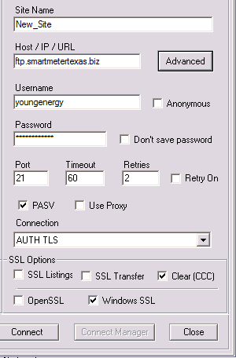

Click Advanced:

This should be shown as below.

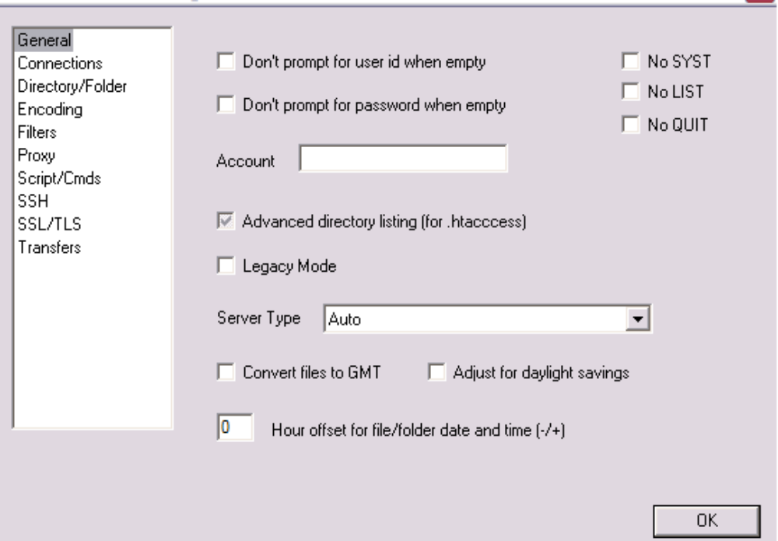

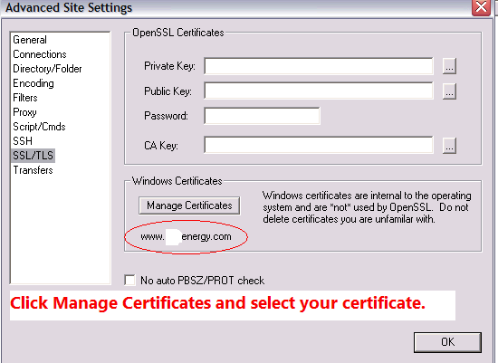

Click Connect and you will get to intervaldata an adhocusage folders. You will be able to retrieve Interval data LSE files from the intervaldata directory. Please follow these steps and let me know the outcome.

